PICO Part A:
Clients with Missing Teeth Who Use Partial Pentures vs Those Who Don’t.
Student: Megan Walbauer.
Faculty: Mrs. Ramesha.
DH 211 Introduction to Research.
Due: June 23, 2024.

Scenario: A 65-year-old client attended her dental hygiene re-care appointment; she has lost several of her teeth to periodontal disease over the last 5 years. Recently she has felt after the loss of her molars, that she is not able to speak properly and avoids eating anything besides soft food because of social embarrassment and because its difficult for her. She has considered replacement options before, but due to financial considerations hasn’t been able to afford a partial denture. After she’s applied and had been accepted for CDCP, her new sun life insurance will cover a partial denture. My client will finally be able to get the treatment she needs to restore her quality of life. The following will outline basic background questions, that are specific to my client.

Background questions:
A.)
Who is the population that is most affected by tooth loss? It’s explained the population that is most affected by oral disease is those who are at an economical disadvantage such as lower income individuals, especially those in developing countries (Pertersen, Bourgeois, Ogawa, Estupinan-Day, Ndiaye 2005). Try to use more recent sources it was also reported that adults with the certain conditions such as heart disease, asthma, rheumatoid arthritis, a fair or poor general health diagnosis, liver conditions and a history of stroke were at a 50% higher chance of complete or partial tooth loss (CDC 2024).
B.)
What is a partial denture? A Partial denture is an appliance that replaces missing teeth in the oral cavity (Fixodent 2024). There are multiple types of partial dentures such as cast metal partial dentures, these are fabricated from a titanium framework with other materials such as resin and acrylic to imitate natural dentition (Fixodent 2024). Another type is acrylic partial dentures, in my own experience these tend to be less resistant to force and had a higher chance of breaking. It’s noted that the acrylic clasps don’t work as well when compared with metal clasps (Fixodent 2024). Lastly, there is flexible partial dentures (Fixodent 2024). The benefit of this is comfort, and aesthetic purposes (Fixodent 2024). However, they are generally more expensive due to the cost of material (Fixodent 2024). Use scholarly sources first, before reverting to websites
C.)
Where in the mouth are most teeth replaced? In a study done in an elderly care facility the most common teeth that were missing are lower first molars and the teeth most likely to retain were lower canines (Catovic, Jerolimov, Catic 2002). In another study done on clients with periodontal disease, maxillary second molars were most commonly lost to periodontal disease and again canine teeth were the most resilient (Matthews, Smith, Hanscom 2001) In my own opinion the most common tooth or teeth missing can also depend on many factors, some would include environment, lifestyle, and access to care. Use more recent sources where available.
D.)
When is it important to consider partial dentures? Consideration for partial dentures can be made for several reasons, normal wear and tear of teeth, periodontal disease, extensive decay and more (Friel, Waia 2020). Principles of partial dentures are to maintain health of remaining teeth while providing support, and restoring function (Friel, Waia 2020). Retention of current teeth can be done through the clasps on partial dentures, in some cases a slot can be milled onto a crown to ensure they fit together, like a puzzle (Friel, Waia 2020). Another thing to consider when planning for partial dentures. is the current health of dentition (Friel, Waia 2020). If teeth have a poor prognosis this should be taken into account in the treatment plan when determining the care option, for example the option should be available to add teeth to a partial should the client need it (Friel, Waia 2020).
E.)
How are teeth lost, in relation to periodontal disease? The cause of tooth loss in periodontal disease is due to destruction of bone and supporting structures of the teeth (Kinane, Stathopoulou, Papapanpu 2017). Periodontal disease will begin as build-up of dental biofilm and will lead to a defense mechanism in the form of inflammation from the body affecting the periodontium, and surrounding bone (Kinane, Stathopoulou, Papapanpu 2017). Bone loss will continue to progress further, unless interventions are made and can ultimately lead to mobility which can result in loss or removal of teeth (Kinane, Stathopoulou, Papapanpu 2017).
F.)
Why do clients need partial dentures? It’s explained that tooth loss affects quality of life, this can be through “Oral Function, Orofacial Pain, Orofacial Appearance, and Psychosocial Impact.” (Scheirz, Baba, Fueki Pg.1 2021). With tooth loss comes the reduced quality of mastication which could result in nutritional concerns, and speaking which affects the day-to-day life of all individuals (Scheirz, Baba, Fueki 2021). The loss of function can result from having less than 20 teeth present in the oral cavity, having no teeth present, and anywhere in between (CDC 2024). Clients can use partial dentures to restore function of chewing, easier ingesting of food, and restoration of overall self-confidence (Saintrain de Souza, 2012).

Identification:
A.) The 65-year-old client is individuals with missing teeth, and the problem is the spaces left from the missing teeth and how that affects clients.
B.) intervention is removable appliances.
C.) The comparison group is clients with no replacement appliances.- this is ok for research purposes, but for CADH and PICO B you will need to use a comparison intervention
D.) The outcome is to restore function of dentition as close to normal for the client.

PICO:
For a client with missing teeth, will partial dentures as compared with no appliance increase the function of dentition?

Question: Therapy and prevention
A.) What is the purpose of a partial denture in clients with tooth loss?

Main topic and key words used to search:
-Partial dentures
-Tooth loss
-Missing dentition
-Who is most at risk for tooth loss?
-What’s the cause of tooth loss?
-Where does tooth loss most often occur in the oral cavity?
-Oral Disease

-Periodontitis
-"Tooth Loss/etiology"[MeSH]
-Most common tooth replaced
- “Jaw, edentulous, partially”
- “Tooth loss/therapy”
-Quality of life*
-Global Health
-Dentures

Need to include the first page of each key word searched in your search engine and circle any MeSH terms.

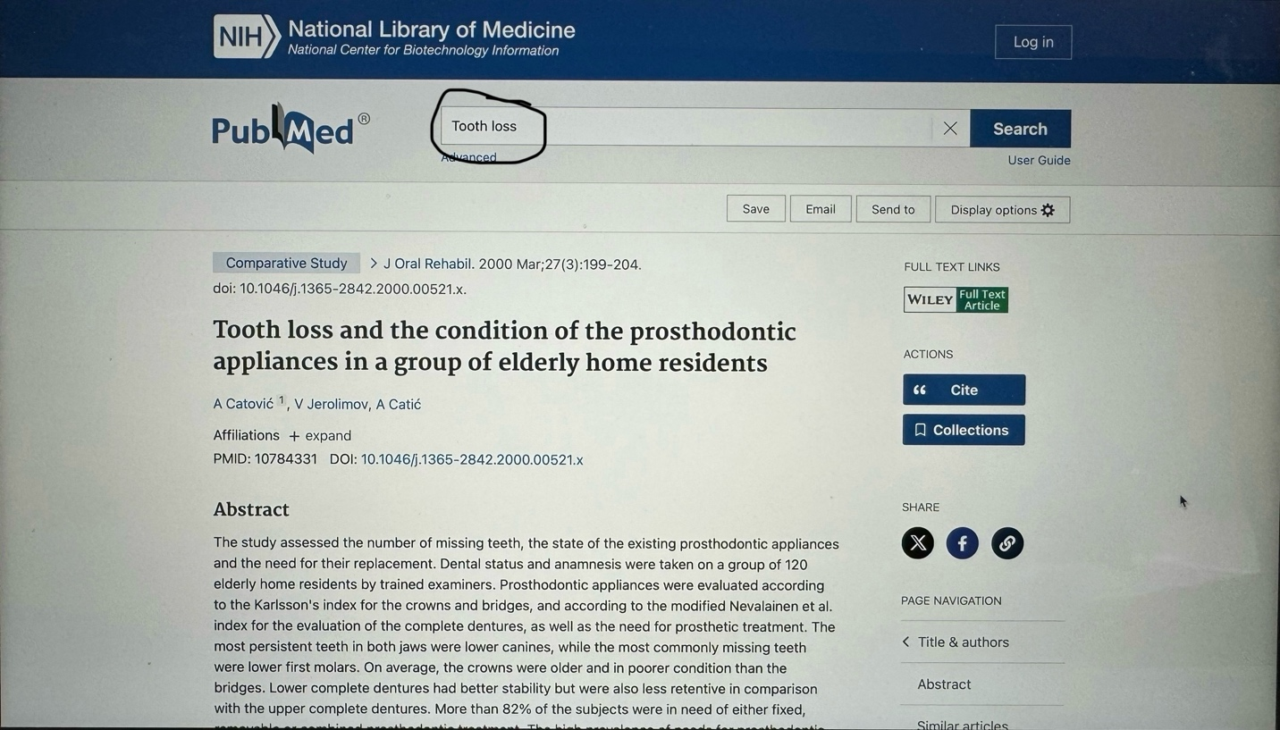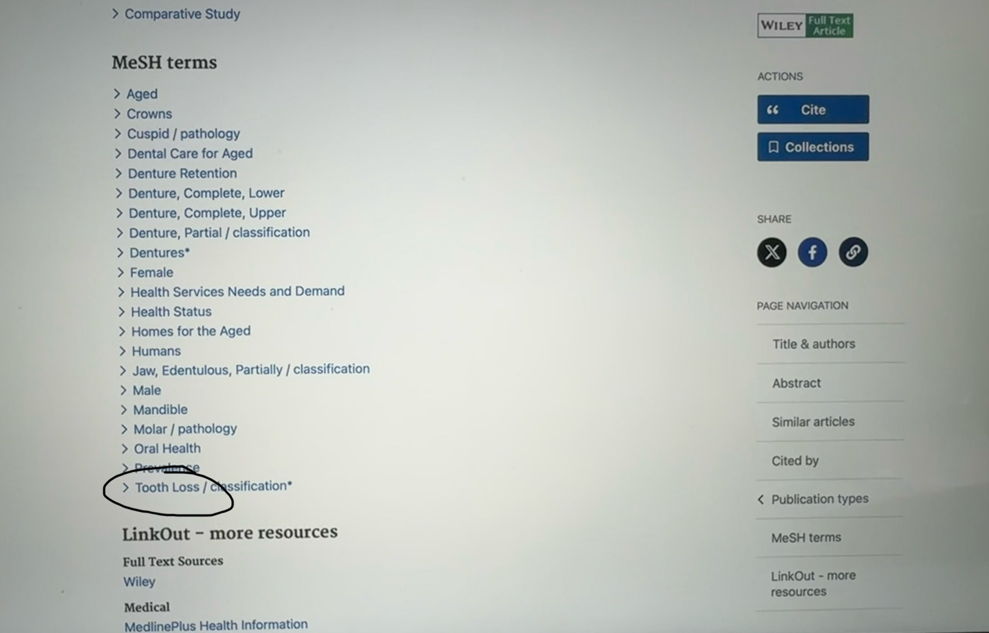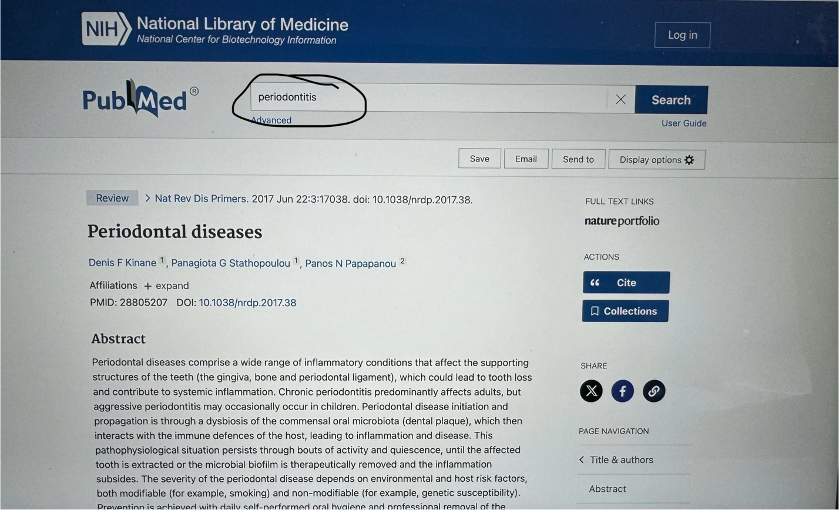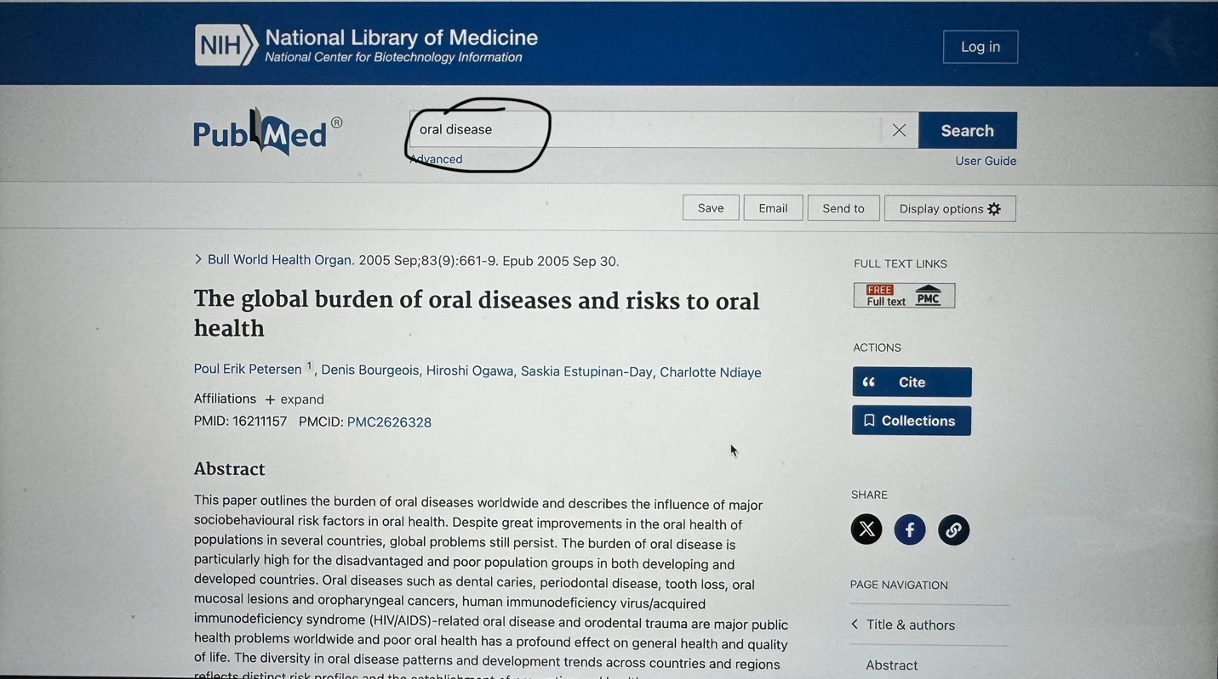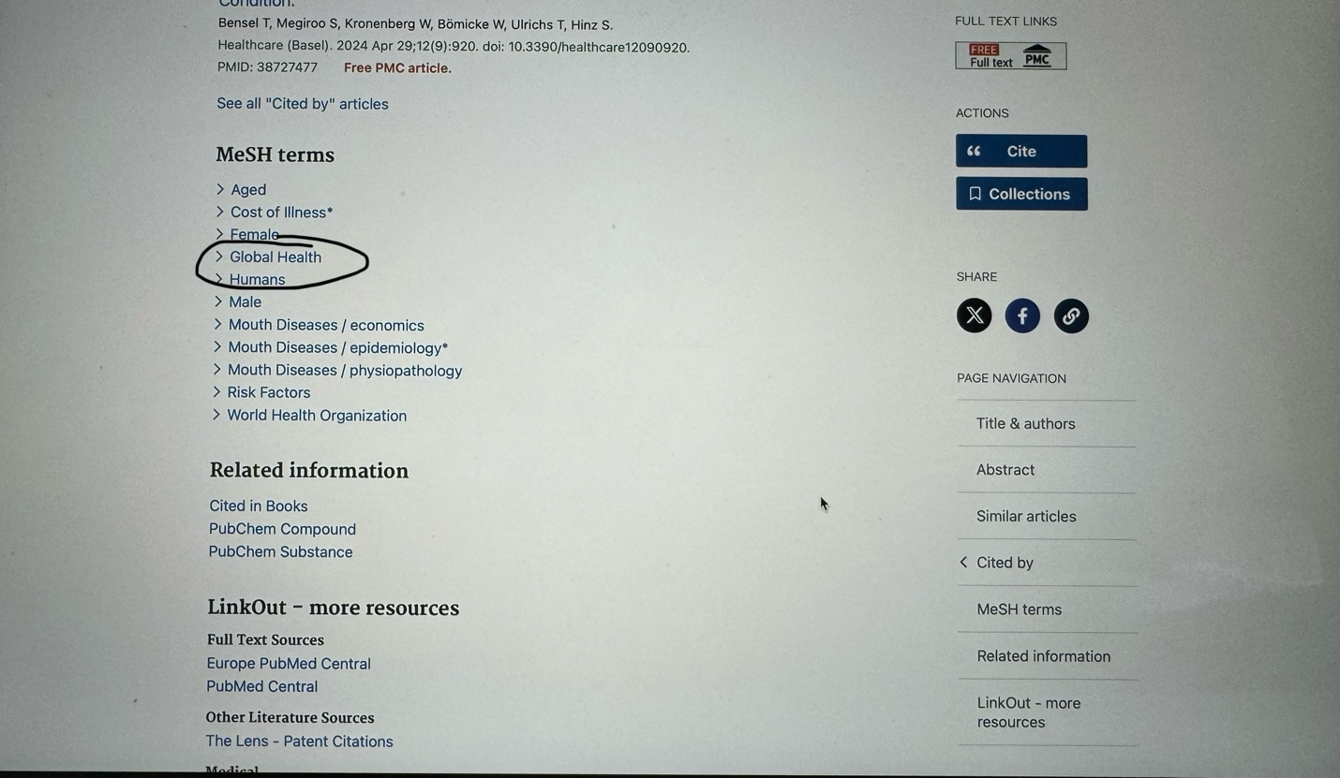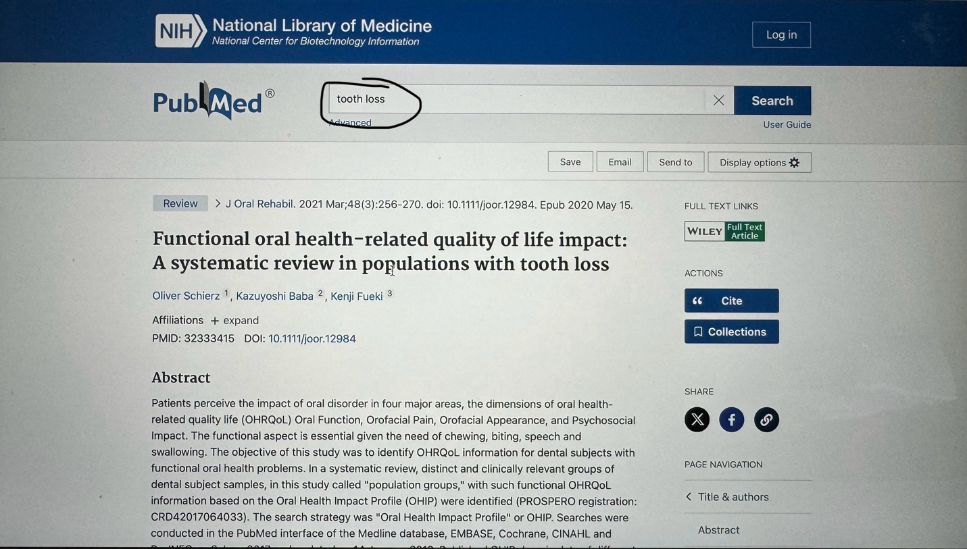

LITERATURE CITED

CDC. About tooth loss. [internet]; 2024 May 15 [Cited June 15, 2024] Available from: https://www.cdc.gov/oral-health/about/about-tooth-loss.html#:~:text=Overview&text=About%201%20in%208%20(13,tooth%20loss%20in%202015–2018.

Catović A, Jerolimov V, Catić A. Tooth loss and the condition of the prosthodontic appliances in a group of elderly home residents. J Oral Rehabil. [Internet]; 2000 Mar [Cited June 15, 2024] Available from: https://pubmed.ncbi.nlm.nih.gov/10784331/

Friel T, Waia S. Removable partial dentures for older adults. primary dent J. [Internet]; 2020 Sept 17 [Cited June 15, 2024] Vol 9 (Issue 3). Available from: https://journals.sagepub.com/doi/full/10.1177/2050168420943435?rfr_dat=cr_pub++0pubmed&url_ver=Z39.88-2003&rfr_id=ori%3Arid%3Acrossref.org

Kinane DF, Stathopoulou PG, Papapanou PN. Periodontal diseases. Nat Rev Dis Primers [Internet]; 2017 Jun 22 [Cited June 15, 2024] Available from: https://pubmed.ncbi.nlm.nih.gov/28805207/

Matthews DC, Smith CG, Hanscom SL. Tooth loss in periodontal patients. J Can Dent Assoc. [Internet]; 2002 [Cited June 22, 2024] Available from: https://www.cda-adc.ca/jcda/vol-67/issue-4/207.html

Petersen PE, Bourgeois D, Ogawa H, Estupinan-Day S, Ndiaye C. The global burden of oral diseases and risks to oral health. Bull World Health Organ [Internet]; 2005 Sep 30 [Cited June 15, 2024] Available from: https://pubmed.ncbi.nlm.nih.gov/16211157/

Saintrain MV, De Souza EH. Impact of tooth loss on the quality of life. Gerodontology. [Internet]; 2011 Aug 24 [Cited June 15, 2024]; Vol 29 (Issue 2) Available from: https://onlinelibrary.wiley.com/doi/10.1111/j.1741-2358.2011.00535.x

Schierz O, Baba K, Fueki K. Functional oral health-related quality of life impact: A systematic review in populations with tooth loss. J Oral Rehabil. [Internet]; 2021 Mar [Cited June 15, 2024]; Available from: https://pubmed.ncbi.nlm.nih.gov/32333415/

What are the different types of partial dentures? Fixodent. [Internet]; 2021 Mar 14 [Cited June, 15 2024] Available from: https://www.dentureliving.com/en-us/advice-tips/types-of-dentures/partials/types-of- partial-dentures
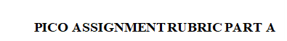
Student Name: ______________Megan Walbauer____________________
 | Value | Grade
- Title page | 1 | 1
- Formulates the background questions by creating general knowledge inquiries about the condition, problem or issue that ask the questions:  - Who  - What  - Where  - When  - How  - Why  Answers each of the background questions identified in part A in a clear and concise manner. | 2  2  2  2  2  2 | 2  2  2  2  2  2
- Begin to define the question using PICO by identifying the  - Patient/Problem____________________  - Intervention _______________________  - Comparison group___________________  - Outcome(s) desired __________________ | 4 | 4
- Writes out the PICO question using the format provided and include the elements patient, client, or population, intervention, comparison group, and outcome(s) desired. | 4 | 4
- Identifies the type of question or problem that is appropriate to the client  - Therapy/prevention  - Diagnosis  - Etiology/causation/harm  - Prognosis | 2 | 2
- Provides a list of the main topics and key words that were used in the search. | 2 | 2
- Provides a copy of the first page of the search conducted for each key term used and circles the MeSH terms. | 2 | 1.5
- Mechanics  - Free of grammatical errors  - Reference Page  - Correct formatting of the reference page | 1  1  1 | 0.5  1  1
TOTAL | 30 | 29
Value to Grade (10%): |  | 97%

Good work HR

 | Value | Grade
- Title page | 1
- Formulates the background questions by creating general knowledge inquiries about the condition, problem or issue that ask the questions:  - Who  - What  - Where  - When  - How  - Why  Answers each of the background questions identified in part A in a clear and concise manner. | 2  2  2  2  2  2
- Begin to define the question using PICO by identifying the  - Patient/Problem____________________  - Intervention _______________________  - Comparison group___________________  - Outcome(s) desired __________________ | 4
- Writes out the PICO question using the format provided and include the elements patient, client, or population, intervention, comparison group, and outcome(s) desired. | 4
- Identifies the type of question or problem that is appropriate to the client.  - Therapy/prevention  - Diagnosis  - Etiology/causation/harm  - Prognosis | 2
- Provides a list of the main topics and key words that were used in the search. | 2
- Provides a copy of the first page of the search conducted for each key term used and circles the MeSH terms. | 2
- Mechanics  - Free of grammatical errors  - Reference Page  - Correct formatting of the reference page | 1  1  1
TOTAL | 30
Value to Grade (10%):

Peer Assessment (5%):
Part B and Peer Assessment Total Grade (20%):

