Comparing Efficacy of Chlorhexidine Rinse and Stannous Fluoride Rinse in Reducing Harmful Plaque Biofilm in the Oral Cavity.

DH 301 Clinical Practice
Faculty: Mrs. H. Ramesha RDH
Student: Megan Walbauer
Client: A.S.
Submission date: November 3, 2024
1. Background questions:
Who is the client: The client is a 29-year-old male with localized stage I grade B periodontitis and generalized chronic moderate-severe diffuse gingivitis. The client has not received professional dental care or dental hygiene care for 15 years. The client consumes a high carbohydrate diet and does not participate in physical activity. My client has also experienced elevated blood pressure at both clinical visits.
What is plaque biofilm: Plaque biofilm is a mixture of microbes and bacteria. This product includes lipids, protein, carbohydrates, and acids and works together to create a biofilm matrix (Jakubovics, Goodman, Mashburn-Warren, Staffor and Ceiplik 2011). The matrix was described as a slime layer and contained a polysaccharide material. (Jakubovics et al 2011). It was noted that twenty percent of plaque biofilm was composed of carbohydrates (Jakubovics et al 2011). The biofilm consists of gram-positive and gram-negative bacteria that forms along tooth structure (Marsh and Bradshaw 1995). It’s noted that there can be over 700 strains of bacteria that can develop over a series of weeks (Rosan and Lamont 2000).
Where does plaque accumulate: Plaque accumulates in the oral cavity subgingival and supragingival (Rosan and Lamont 2000). It forms on all surfaces of the tooth including interdental areas (Rosan and Lamont 2000). It can also form on soft tissues. To note the host can also have an effect on plaque accumulation (Jakubovics et al 2011). When plaque is developed below the gumline it becomes exposed to gingival crevicular fluid, in those fluid it has a different range of the host inflammatory cells and can be a sufficient substance for the growth and development of plaque biofilm (Jakubovics et al 2011).
When is the use chlorhexidine rinse and stannous fluoride rinse useful: The use of these products may be useful when oral inflammation is unable to be properly controlled or when oral disease is present. In addition, when plaque biofilm is present at an elevated level. A study showed that both stannous fluoride and chlorhexidine were effective in reducing plaque index values (Svantun, Gjermo, Eriksen, and Roslla 2009).
How does plaque biofilm develop: Development of plaque biofilm begins through adherence of microbes and bacteria to a surface, these can include tooth surfaces, or gingival surfaces (Seneviratne, Zhang, and Samaranayake 2011). The mixture of saliva and bacteria initiates the production and begins to multiply into microscopic colonies (Seneviratne, Zhang, and Samaranayake 2011). These colonies then become embedded to the surface and form a layer called the acquired pellicle (Seneviratne, Zhang, and Samaranayake 2011). These colonies secrete a substance that acts as a pillar, protection, and aids in further development (Seneviratne, Zhang, and Samaranayake 2011). Primary bacteria set the process in motion and secondary bacteria aids in further accumulation (Seneviratne, Zhang, and Samaranayake 2011). When these products are left for an extended period, it can create a harmful three-dimensional structure that causes inflammation of surrounding tissues (Seneviratne, Zhang, and Samaranayake 2011).
Why does plaque biofilm develop: Plaque biofilm develops because it is like the rest of the body, exposed to elements (Seneviratne, Zhang, and Samaranayake 2011). The oral cavity will become exposed to bacteria, food sediment, saliva, and other fluids (Seneviratne, Zhang, and Samaranayake 2011). All areas of the body are composed of resident bacteria, microbes and are part of specific properties (Seneviratne, Zhang, and Samaranayake 2011). oral plaque biofilm is involved and specific to each individual (Seneviratne, Zhang, and Samaranayake 2011).
Identification:
Patient: A 29-year-old male with high plaque index, localized stage I grade B periodontitis, and generalized chronic moderate-severe diffuse gingivitis.
Intervention: Chlorhexidine rinse
Comparison: Stannous fluoride rinse
Outcome desired: The outcome is to reduce plaque biofilm in the oral cavity.

PICO:
For a 29-year-old patient with a high biofilm score will chlorhexidine products as compares to stannous fluoride products reduce plaque biofilm in the oral cavity.

Question: Therapy/prevention
How does the use of chlorhexidine in comparison to stannous fluoride mouth rinse affect plaque biofilm?

Main topics and key words used to search:

Chlorhexidine:
- Chlorhexidine vs stannous fluoride.
- Chlorhexidine mouth rinse.
- Chlorhexidine.

Stannous fluoride:
- Stannous fluoride.
- Stannous fluoride mouth rinse.

Biofilm:
- Dental plaque biofilm.
- Plaque biofilm accumulation.
- Bacteria in dental plaque biofilm.

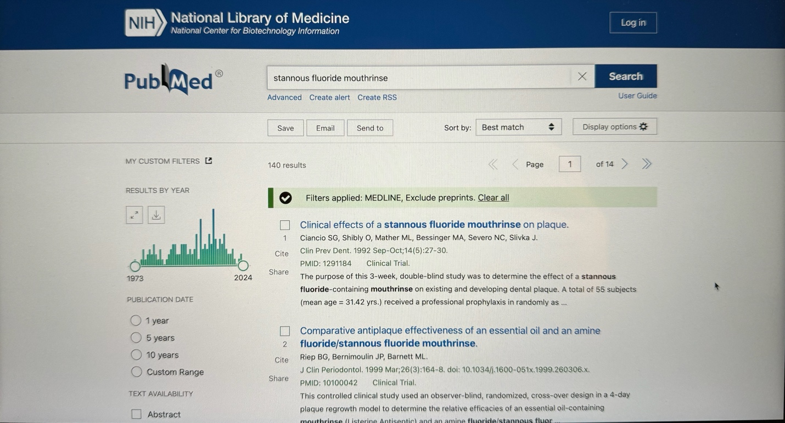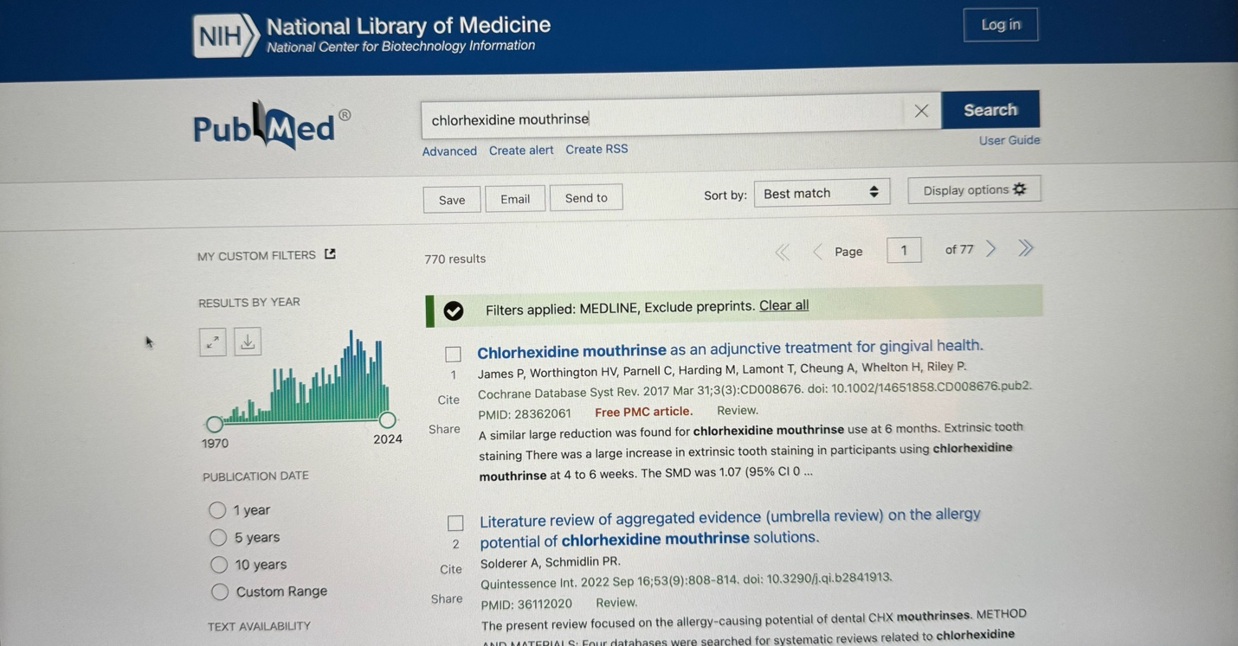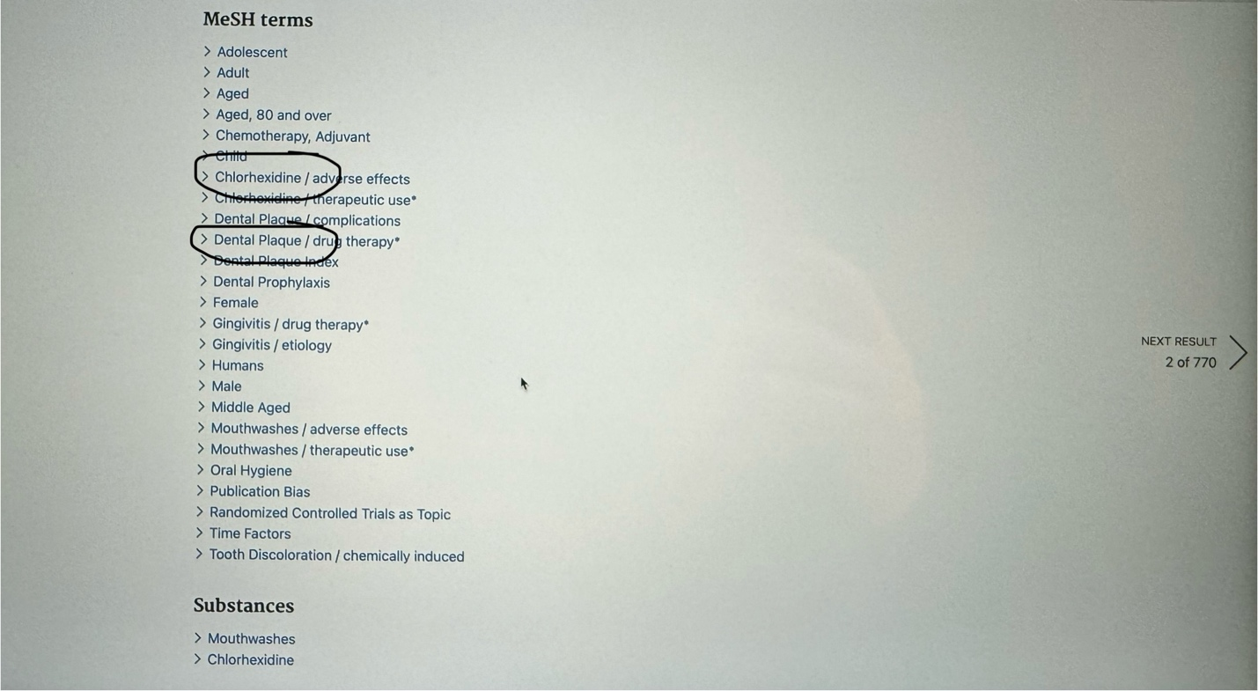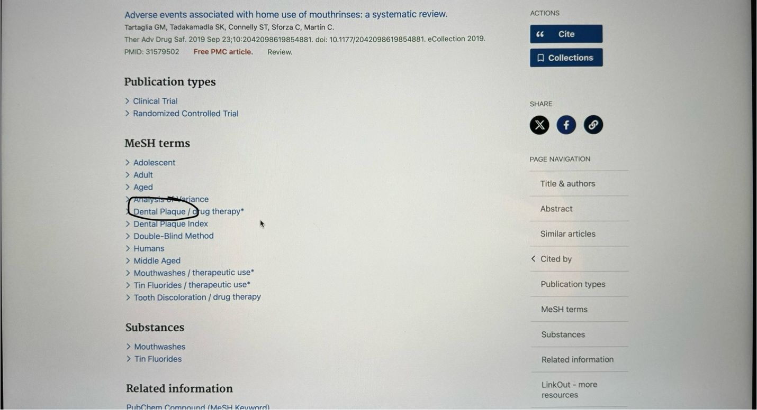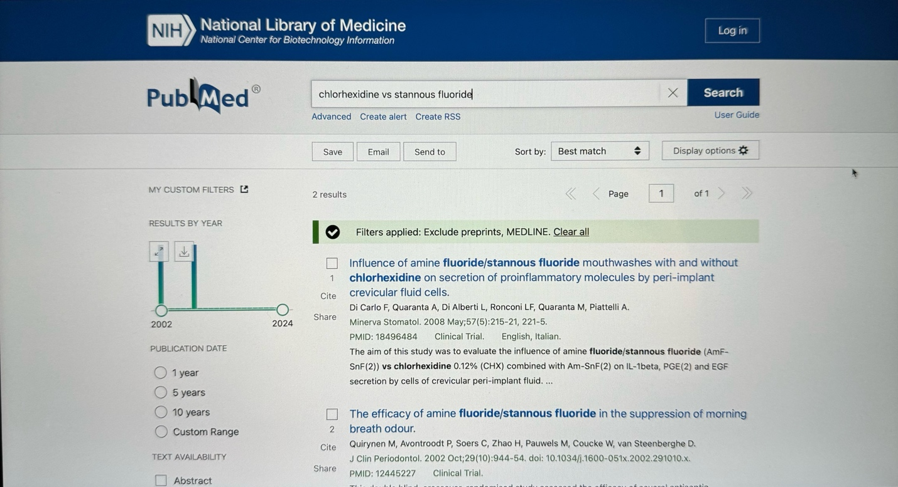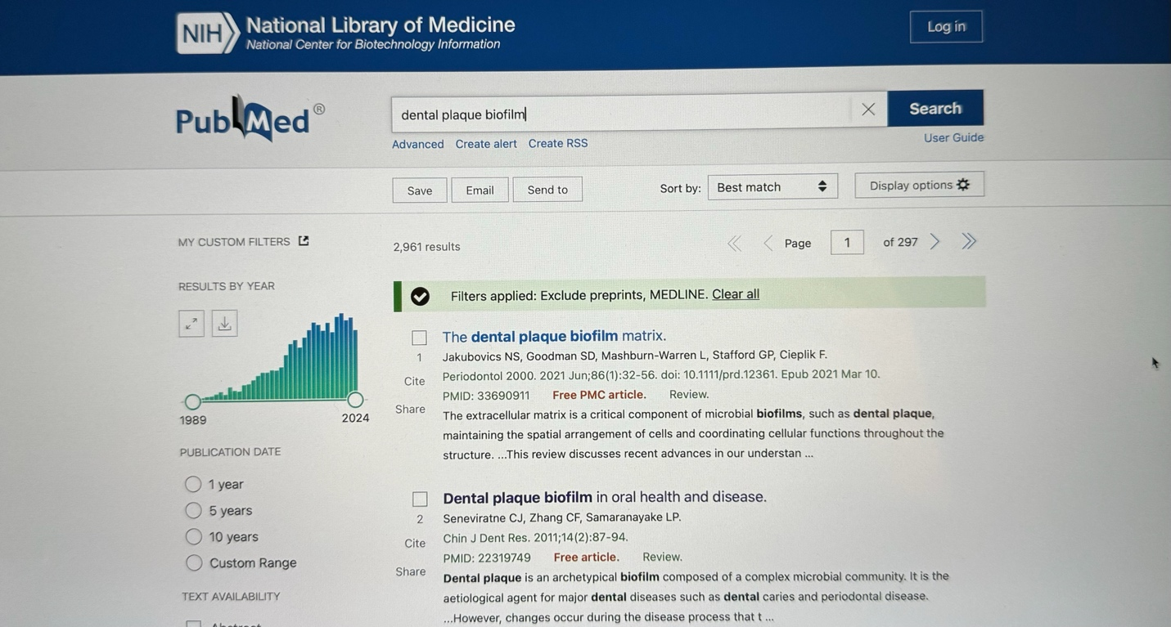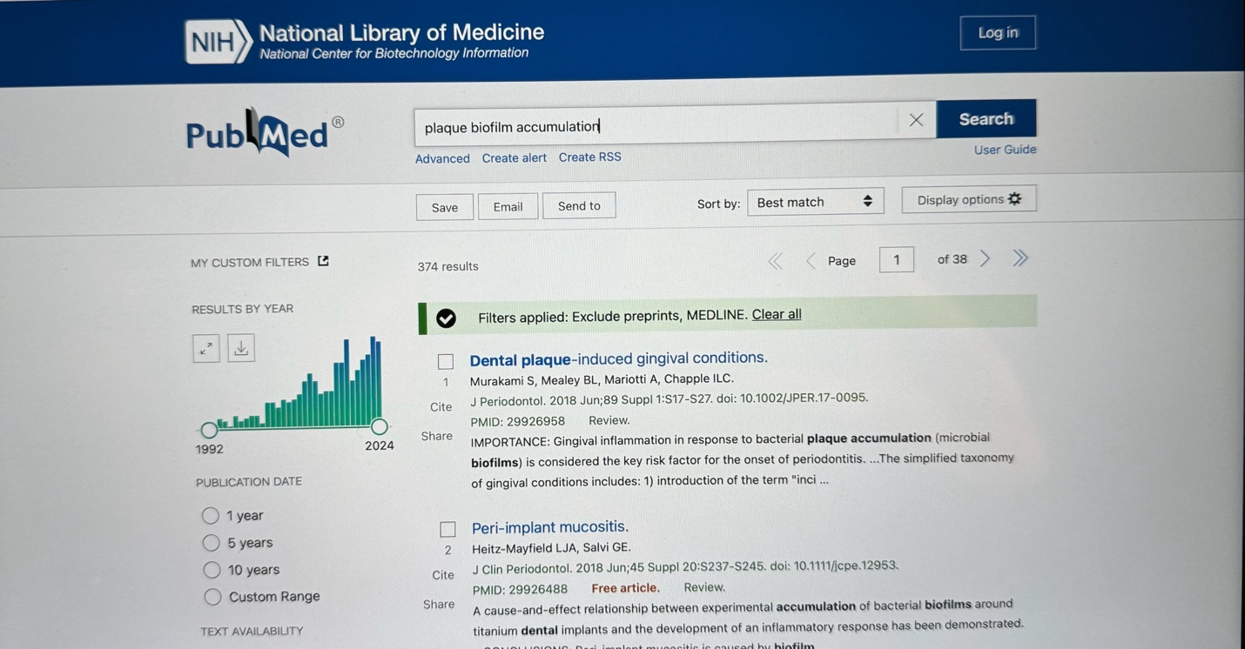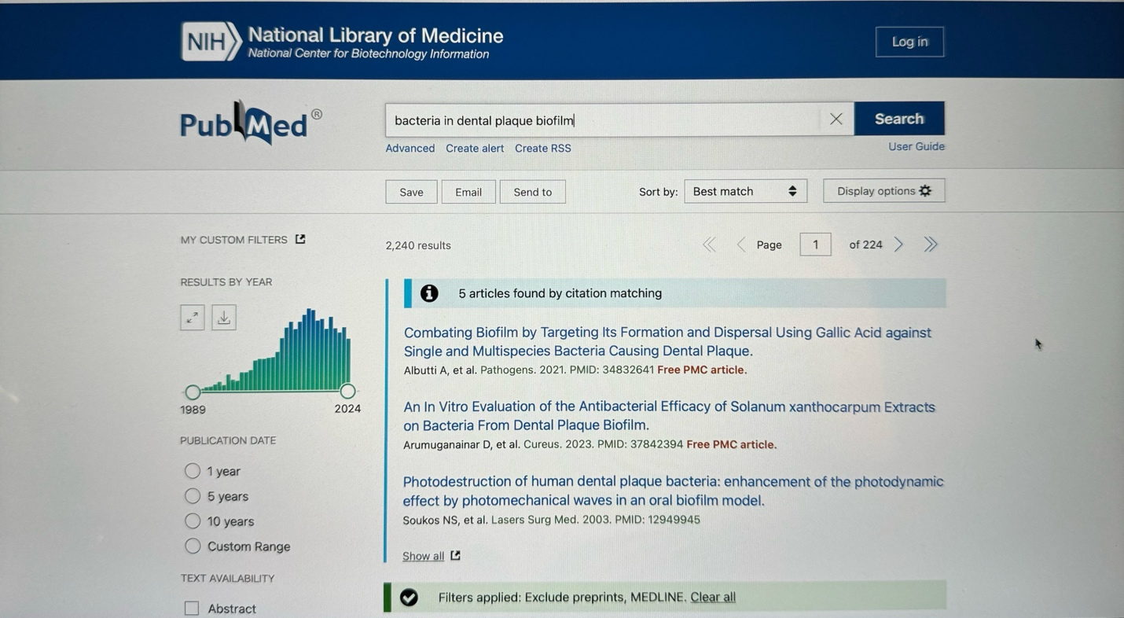

PICO Paper
Dental plaque biofilm remains a growing concern in dentistry, and although we will never be rid of this, there are products that can be used to aid those suffering from reversible and irreversible dental disease. My client presented with a high plaque biofilm score and moderate to severe gingivitis. In an attempt to aid my client further this paper will draw the conclusion of which product will have the higher benefit. Either chlorhexidine or stannous fluoride mouth rinses. It will discuss the benefits and drawbacks of both and how they work on the oral cavity and most importantly the relation to dental plaque biofilm.
The use of chlorhexidine with its antimicrobial properties has been proven to effectively reduce gingivitis (James, Worthington, Parnell, Harding, Lamont, Cheung, Whelton, and Riley 2017). A study was conducted over a four-to-six-week time period and was proven when used in addition to oral hygiene home care when it was compared to the use of no mouth rinse (James et al 2017). However, a disadvantage with the use of chlorhexidine would cause staining and can be conclusive with other side effects such as affected taste, disturbance of oral mucosa and even calculus formation (James et al 2017). Chlorhexidine has been used for a number of years in the dental field and remains a top competitor when it is related to other rinses (Jones 1997). Chlorhexidine effect is described as through the use of “persistence of antimicrobial effect at the tooth surface, through both bactericidal and bacteriostatic effects” (Jones p.1, 1997). With that chlorhexidine’s benefit is also its drawback, again due to the substance of the chlorhexidine molecule the results in staining (Jones 1997). To the defense of chlorhexidine, it can provide great value to clients who would benefit most, such as those with limited dexterity or inability to control dental disease (Jones 1997).
Stannous fluoride is proven to have benefits that are related to the properties of its ingredients (Fiorillo, Cervino, Herford, Laino, and Cicciu 2020). Stannous fluoride has the ability to form a protective layer on the enamel layer of dentition (Fiorillo et al 2020). A Double-blind study was done to determine the effect that stannous fluoride rinse had on dental plaque, this resulted in a significantly lower plaque index than the participants who had used stannous fluoride mouth rinse versus those who did not (Ciancio, Shibly, Mather, Bessinger, Severo, and Silvka 1992). Another study was done over a twelve-day period where participants were tested with stannous fluoride for five days then had two days break and used a placebo for five days and was measured in between (Tinanoff, Camasci, and Hellden 1980). The results indicated a significant reduction in plaque and the number of bacteria that was included per milligram of plaque with those after the use of stannous fluoride rinse (Tinanoff, Camasci, and Hellden 1980).
To Compare the two products there is no doubt that both products work to reduce dental plaque biofilm, however one will triumph over the other. A double-blind clinical trial tested the plaque inhibition between twelve dental hygiene students and was noted that the stannous fluoride plaque index was slightly higher than the chlorhexidine rinse (Svantun, Gjerma, Eriksen, and Roslla 1977). This study also indicated there was less of a staining problem than had been previously reported by other studies (Svantun Gjerma, Eriksen, and Roslla 1977). Another clinical study that was performed on four adults that compared both stannous fluoride and chlorhexidine explained that chlorhexidine was more effective in several areas that include plaque index, bacteria colony formation, and plaque weight (Hellden, Camosci, Hock, and Tinanoff 1981). In addition, another study was done over a four-day period that tested slurries of both stannous fluoride paste and chlorhexidine products where no other form of oral hygiene techniques were used. The result was that significantly less with plaque regrowth and even went on to explain that the use of products with known benefits are useful for comparison of studies indicating that was chlorhexidine (Addy, Jenkins, and Newcombe 1990). Lastly a study was done on post-surgical mouth rinses in an attempt to reduce bacteria and biofilm in surgical periodontal therapy. This study was conducted over twelve weeks and showed that both exhibited comparable but exponential improvements, and plaque control management (Horwitz, Machtei, Peled, and Laufer 2000).
In this case I feel based on the research done that chlorhexidine would be the most beneficial solution for my client. These products display the inevitable that they must be used in conjunction to effective oral hygiene techniques. Chlorhexidine is proven to work and would be a dose specific product that would effectively control plaque for my client (Horwitz, Machtei, Peled, and Laufer 2000).

CANADIAN ACADEMY OF DENTAL HEALTH AND COMMUNITY SCIENCES
a Division of the Canadian Academy of Dental Hygiene Inc. Est 2001
PICO Summary
Client name: AHMED, Syed Student name: Megan Walbauer Date: November 2, 2024
1. Write out PICO question including all aspects of client specific problem.
For a 29-year-old patient with a high biofilm score will chlorhexidine products as compares to stannous fluoride products reduce plaque biofilm in the oral cavity. The client also presented with localized stage I grade B periodontitis and generalized chronic moderate-severe diffuse gingivitis. The client has not received professional dental care or dental hygiene care for 15 years. The dental history for the client was he expressed to brush once a day with a manual toothbrush.

2. Using evidence-based decision-making (EBDM), briefly describe the conclusion drawn from your research.
The conclusion of the research was that both products were sufficient in controlling and reducing dental plaque biofilm based on the studies found (James, Worthington, Parnell, Harding, Lamont, Cheung, Whelton, and Riley 2017). A few studies indicated a better result with chlorhexidine mouth rinse, in addition that chlorhexidine is an evidence proven product and remains effective (Svantun, Gjerma, Eriksen, and Roslla 1977). Chlorhexidine works through bactericidal and bacteriostatic effects (Jones 1997) Chlorhexidine does pose a disadvantage of staining and was noted with the research articles utilized for this (Jones 1997). Stannous Fluoride works by forming a protective layer on the dentition and was effective in a study when compared with no rinse in reducing the amount of dental plaque (Fiorillo, Cervino, Herford, Laino, and Cicciu 2020). Stannous fluoride rinse also noted a reducing in the bacteria of the biofilm (Tinanoff, Camasci, and Hellden 1980). When compared to each other chlorhexidine had a better outcome for the studies researched.

3. Summarize the specific recommendation(s) made to the client.
Based on the two products researched, I feel that chlorhexidine mouth rinse will better benefit my client. Chlorhexidine is proven to work and would be a dose specific product that would effectively control plaque for my client (Horwitz, Machtei, Peled, and Laufer 2000). I feel this is the best choice due to the status of the clients gingival and periodontal disease, and because it is proven to be effective in the reduction of plaque and bacteria (Hellden, Camosci, Hock, Tinanoff 1981). The rinse will be doing more than just protection and should benefit the client’s chronic condition. The process to obtain this product would be through a dentist, and applicable through an end of care referral. The mouth wash would be attainable if the dentist felt it would benefit the client, it would be prescribed by either the dentist or certified registered dental hygienist and would able to be picked up at your local pharmacy (GoodRx 2023). To appropriately use this product is to rinse and swish the solution in your mouth for 30 seconds and spit it out (HealthLinkBC 2024). The product will include a measuring cup and the recommended dose is 15ml normally twice a day (HealthLinkBC 2024). It’s advised to not swallow the solution and to ensure the appropriate dosage is used for the best result of treatment, in addition the pharmacist will guide you on how to deal with a late dose or missed dose (HealthLinkBC 2024). Reactions and side effects include the following, mouth irritation, dry mouth, change of taste in foods, skin rash, and itching or swelling (HealthLinkBC 2024). If any serious reactions occur seek medical attention and consult pharmacist (HealthLinkBC 2024).

PICO Delivery Date: _______________ Client Signature: _____________________________
Student Signature: _________________ Faculty Signature: ____________________________
LITERATURE CITED

Addy M, Jenkins S, Newcombe R. The effect of triclosan, stannous fluoride and chlorhexidine products on: plaque regrowth over a 4-day period. [internet] Nov 1990 [Cited Nov 1, 2024]; Available from: https://onlinelibrary.wiley.com/doi/abs/10.1111/j.1600-051X.1990.tb01055.x
Ciancio SG, Shibly O, Mather ML, Bessinger MA, Severo NC, Silvka J. Clinical effects of a stannous fluoride mouthrinse on plaque. [Internet] Oct 1992 [Cited Nov 1, 2024]; Available from: https://pubmed.ncbi.nlm.nih.gov/1291184/
Fiorillo L, Cervino G, Herford AS, Laino L, Cicciu M. stannous fluoride effects on enamel: a systematic review. [internet] Aug 31, 2020 [Cited Nov 1, 2024]; Available from: https://www.mdpi.com/2313-7673/5/3/41
GoodRx. Chlorhexidine. [Internet] July 20, 2023 [Cited Nov 7, 2024]; Available from: https://www.goodrx.com/chlorhexidine/what-is#
Hellden L, Camosci D, Hock J, Tinanoff N. Clinical study to compare the effect of stannous fluoride and chlorhexidine mouthrinses on plaque formation. [Internet] Feb 1981 [Cited nov 1, 2024]; Available from: https://onlinelibrary.wiley.com/doi/abs/10.1111/j.1600-051X.1981.tb02019.x
HealthLinkBC. Chlorhexidine Gluconate Rinse – Oral. [Internet] 2024 [Cited Nov 7, 2024]; Available from: https://www.healthlinkbc.ca/medications/chlorhexidine-gluconate-rinse-oral#:~:text=not%20get%20pneumonia.-,How%20To%20Use,and%20then%20spit%20it%20out.
Horwitz J, Machtei EE, peled M, laufer D. Amine fluoride/stannous fluoride and chlorhexidine mouthwash as adjunts to surgical periodontal therapy: A comparative study. [Internet] Oct 1, 2000 [Cited Nov 1, 2024]; Available from: https://aap.onlinelibrary.wiley.com/doi/abs/10.1902/jop.2000.71.10.1601
Jakubovics NS, Goodman SD, Mashburn-Warren L, Stafford GP, and Ceiplik F. The dental plaque matrix. [Internet] 2011 [Cited Nov 1, 2024]; available from: https://onlinelibrary.wiley.com/doi/full/10.1111/prd.12361
James P, Worthington HV, Parnell C, Harding M, Lamont T, Cheung A, Whelton H, and Riley P. Chlorhexidine mouthrinse as an adjunctive treatment for gingival health. [Internet] 2017 [Cited Nov 1, 2024]; Available from: https://pubmed.ncbi.nlm.nih.gov/28362061/
Jones CG. Chlorhexidine: is it still the gold standard? [internet] 2000 [Cited Nov 1, 2024]; Available from: https://pubmed.ncbi.nlm.nih.gov/9643233/
Marsh and Bradshaw. Dental plaque as a biofilm. [Internet] 1995 [Cited Nov 1, 1995]; Available from: https://academic.oup.com/jimb/article/15/3/169/5988575?login=false
Rosan B and Lamont RJ. Dental plaque formation. [Internet] 2000 [Cited Nov 1, 2024]; Available from: https://www.sciencedirect.com/science/article/pii/S1286457900013162
Seneviratne CJ, Zhang CF, and Samaranayake LP. [Internet] 2011 [Cited Nov 1, 2024]; Available from:https://www.quintessence-publishing.com/deu/en/article-download/851685/chinese-journal-of-dental-research/2011/02/dental-plaque-biofilm-in-oral-health-and-disease
Svantun B, Gjerma P, Eriksen HM, Roslla G. A comparision of the plaque-inducing effects of stannous fluoride and chlorhexidine. [internet] April 30, 1997 [Cited Nov 1, 2024]; Available from: https://www.tandfonline.com/doi/epdf/10.3109/00016357709019799?needAccess=true
Tinanoff N, Hock J, Camasci D, Hellden L. Effect of stannous fluoride mouthrinse on dental plaque formation. [Internet] June 1980 [Cited Nov 1, 2024]; Available from: https://onlinelibrary.wiley.com/doi/abs/10.1111/j.1600-051X.1980.tb01966.x

